Building a Vibrant, Healthy, Growing Church
Petr Činčala, MDiv, MSW, PhD
Institute of Church Ministry
Andrews University

Introduction
Not everybody can say they literally grew up in the local church. I did. I went from the hospital to a church building and stayed there till I left my parents as an adult. Pastors typically move every seven years, so yes, I grew up in three church buildings with my parents and siblings. Church has been my world, my reality, my everything. It was also my love for the church that gave me courage to “leave” for about 10 years, and to live and work among unchurched people as a missionary.
This paper comes out of the recent research conducted by the Institute of Church Ministry, of which I am the director. With a trembling heart I take the opportunity to share my findings about building a vibrant, healthy church.

Historical background of the problem
Churches used to be strong in United States, sending missionaries, starting mission societies, and developing new methodologies to reach out not just individual people, but also entire people groups. When studying at the Seminary 20 years ago, I heard from my teachers about Donald McGavran, Peter Wagner, and other experts on Church growth who were writing methodological books and giving hope to many rising leaders that the church would continue to grow, fulfilling its purpose and stay dominant in society. However, their books were put aside when pastors who grew churches from nothing to 10, 15, 20 thousands or more came out with their own books. The focus shifted slowly from church growth formulas and methodologies to successful church models that were blowing people’s minds; soon after, a number of pastors from all kinds of denominations (including the Seventh-day Adventist church) were copying and imitating these models, hoping it will bring similar results and fruits; rarely did it meet their expectations to the full extent.
Whereas the books in 1970s and 1980s were focused in providing “magic formulas” (for numbers) and expert methodologies for church growth (summary in Wagner, 1987), the emphasis shifted more towards building vital and healthy churches with focus on quality (Johnson 1989; Miller 1990; Spader et al. 1991; Shawchuck & Rath 1994:143; Stetzer & Puttman 2006:46-48). Experts from the academic world no longer represented church growth, but were replaced by pastors such as Warren and Hybels and their model of a “Purpose Driven Church” (Warren 1995) and “Seeker Sensitive Model” (Hybels 1995). Numerous pastors from around the world have tried to imitate their model with varied results.

Missional Matrix
About a decade later yet another focus emerged that surpassed the “anthropocentric emphasis on tools and techniques, or methodology” (Stetzer & Puttman 2006:55). Focus on healthy churches gradually shifted to a discussion about missional churches (Guder 1998; Gelder 2007; Roxburgh 2011; Wegner & Magruder 2012; Woodward 2012). With growing globalization and increasing secularization the distance between mission and church started to wear off. Both theologians and practitioners realized more and more that “a church without mission is . . . theologically absurd. Without mission there is not church” (Hegstad 2013:82).
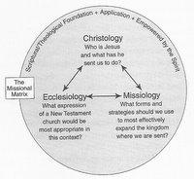
Deeper understanding of Triune God has helped to find a new meaning of what mission is (Bosch 1991). The recently derived term “missional” goes beyond the idea of Christian presence in every country and or language. It refers to mission in various segments of population, cultural or subcultural settings, or groups of people (Stetzer & Putmann 2006:3). Reaching people with the gospel no longer means just preaching the Gospel but breaking through all kinds of barriers to help people to understand, as well as experience, God and His presence.
Stetzer & Putmann came up with a term Missional Matrix, explaining how mission Dei (God’s mission) permeates teaching about Christ (Christology), teaching about mission (missiology) and teaching about church (ecclesiology) and moreover, how the three areas interact together and provide a balanced Biblical foundation for our theology, as well as for our practice (2006:8-9). The implications are profound because it empowers local churches to be at the mission front-line, reaching out to their communities. This often requires thinking through their methods of reaching people and using not only canned approaches (2006:45). It may, at times, require doing things they do not like or feel comfortable with (2006:50).

Christology = Be like Christ
Christ is important to us as Seventh-day Adventists. His Second Coming is so essential to us our name is derived from this belief. Christ’s ministry in the Heavenly Sanctuary plays an important role in our fundamental beliefs, as well. Because of this, before we get excited about mission and ways to reach people for Christ, before we even invite them to come to our church, it is important for us to listen carefully to what Jesus said. We must follow the ministry model he exhibited, pay attention to what he wants, and understand who He is (i.e. what authority is His commission based on). Jesus was quite consistent in focusing on values and principles related to God’s kingdom. Before we baptize thousands and bring them to churches, let’s think again about how can we be more like him in what we teach and how we go about it:
“Not only our purpose is defined by the person and work of Jesus, but our methodology as well. . . It is Christ who determines our purpose and mission in the world, and then it is our mission that must drive our search for modes of being in the world” (Hirch 2009:143).
As Alex Bryan reminds us, Christology precedes ecclesiology (2016:4). Missiology too comes from understanding of the nature of Christ, His mission, and His commission. He said, “as the Father has sent me, I am sending you” (John 20:21). How we go about mission “flows from our understanding of God’s mission” (Stetzer & Puttman 2006:53).
We also need to pay attention to the Spirit Jesus sent to lead us to the truth of the Scriptures (John 16:13) that testify primarily about Jesus (John 5:39). “God’s action in Jesus Christ by the power of the Holy Spirit is the key to understanding Christian mission” (Snyder & Runyon 2002: 127).

Missiology = Reach Like Christ
The Seventh-day Adventist Church has put a great emphasis on mission in the last decades. I remember past initiatives such as “1000 Days of Harvest”, Harvest 90, and Global Mission Pioneers. The church has grown from 2 million in 1970 to 18.5 million in 2015, which is tremendous growth. Presently, there is a new Total Member Involvement initiative (tmi.adventist.org) being implemented; the early results are fascinating. One specific event comes out – a mega baptism of one hundred thousand new believers in Rwanda. This shows great zeal for teaching people the truths of Scripture, and much emphasis on preparing them for the Second Coming of Jesus.
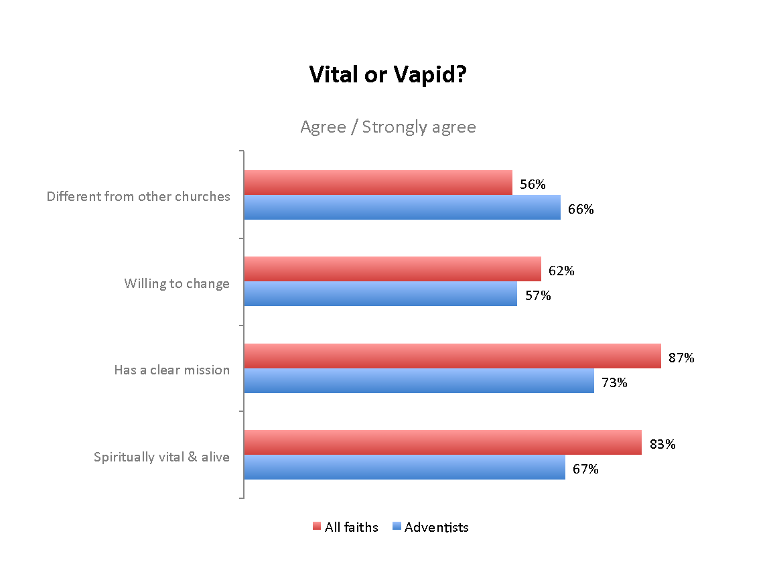
A recent interfaith research report, which will be discussed in the next part of this study, shows less than three out of four SDA churches in North America have clear sense of mission, and only two thirds of SDA congregations claim they are spiritually vital and alive (see chart). What exactly is mission of local churches? “Church does not create its own mission; it is the mission of God that creates the church” (Frost in Hill 2012:xi).
Because the “church is called—above all—to be a missionary church” (Andiñach 2014: 46), missiology is essential as it helps the church carry out its mission. Missiology is no longer considered a study related to remote mission fields. Instead, it is:
- a discipline clarifying the meaning of what church actually is,
- a discipline helping the church to understand the surrounding community,
- a discipline finding most effective ways of reaching out lost people for Christ in that community (Stetzer & Puttman 2006:53).
Missiology therefore plays very important role. Stetzer & Puttman go as far as to say “if we are not focusing on missiology, then we are being disobedient to the Great Commission” (2006:2).

Ecclesiology = Relate Like Christ
There is an ongoing discussion about missional ecclesiology among evangelical theologians. As mentioned earlier, mission is no longer as something the church does, not something distant, not an addition to church life “or even something church can do without.” The very nature and essence of church is being sent—being a “missionary,” “missional,” or “mission-shaped” (Hegstad 2013: 82). We believe the church should have its existence and purposes anchored in the Bible and in the teaching of Jesus (Lewis & Cordeiro 2005: 18).
With significant emphasis on evangelism and mission, it is good to ask how our church is doing in retaining and reclaiming people. The North American Division Secretary’s report states that one third of members left the church in last 8 years. Two thirds of young adults have left the church (Bryant 2016:39-40). As we are exploring “missional matrix” of church, it may be appropriate to ask what is church and how is it supposed to play out.
The basic Biblical portrait of church is a body of believers (Hegstad 2013:2). “Biblical images of church are organic, not static or institutional” (Snyder & Runyon 2002:14). As fervent readers of Scripture, we understand the church “as an organic community rather than as a hierarchical institution” (2002:130). Yes, over time even the church we are part of has become institutionalized, acquired buildings, organizations, “committees, meetings, programs, and traditions, none of which may be wrong in themselves” (Chester & Timmis 2008: 86); however, they have shifted the main priorities from the church as Christ’s community of believers.
Church and its mission “must be coherent with each other” (Snyder & Runyon 2002:127). There is a need for genetic compatibility between the church and its mission, the same DNA. “Every part of church’s life, ministry, and mission must find their focus and their power is Jesus Christ. Jesus is the one who holds all things together and gives unity to all that the church is called to do” (2002:127-128). “While there is no ideal or universal model of the church presented in Scripture, our ecclesiology is to be grounded in, and measured by the commands, witness, and revelation of Scripture.” (Hill 2012:xxii).
As God exists in a loving community, so is the church called to live. It is not possible to love a God we do not see, and not care passionately for our fellow believers regardless of age, gender, status, or cultural background (1 John 4:20). The primary identifier of Jesus’ disciples is “love for one another” (John 13:35). “When we are in harmony with God through Jesus Christ by the Spirit, we are potentially in harmony with every other person and with the cosmos” (Snyder & Runyon 2002:131-132). In letters written by apostle Paul, we repeatedly witness his main concern is how Christians interact with each other in local churches. For Paul, to be Christian meant having close relations with other Christians, to treat each other well (Rice 2014).
The Bible has not presented an ideal or universal model of the church. There may be traditional churches that will not be able to make radical cultural shifts to embrace new generations; however, they can still support missional renewal and provide loving and prayerful support not only for its own members, but also for those who found new shapes for the church and allowed it to form “in unique, Spirit-directed ways” (Beach 2015:152-153). Missional ecclesiology is therefore dealing with churches that are the most appropriate expressions of New Testament church in the context of what Christ has sent us to do (Stetzer & Puttman 2006:53).

Vital or Vapid?
As already mentioned, in this section we are assessing the Seventh-day Adventist (SDA) church in the North American Division (NAD). When you think of your church, is it growing? Would you consider it vital and full of life? Or, would you instead consider it vapid – slowly dying?
To answer these questions, the Institute of Church Ministry (ICM) team at Andrews University looked into the findings of a Faith Communities Today oversample report among SDA congregations. This survey of 324 churches was conducted in 2015, as well as in previous years, and included a comparison with the general national sample. The ICM team also looked into one of the largest survey databases in the United States on quality of church life (Natural Church Development survey) that contains 347,849 surveys collected between 2008 and 2016 among active church members across various denominations – including the SDA church (28,811 surveys).
One of the most evident indicators of a church’s vitality is church membership and attendance. In that area, the SDA church showed encouraging growth! Between 2009 and the end of 2014, office SDA membership grew 8.5%. Additionally, the average weekly attendance of SDA churches has gone up 22% between 2009 and 2015.
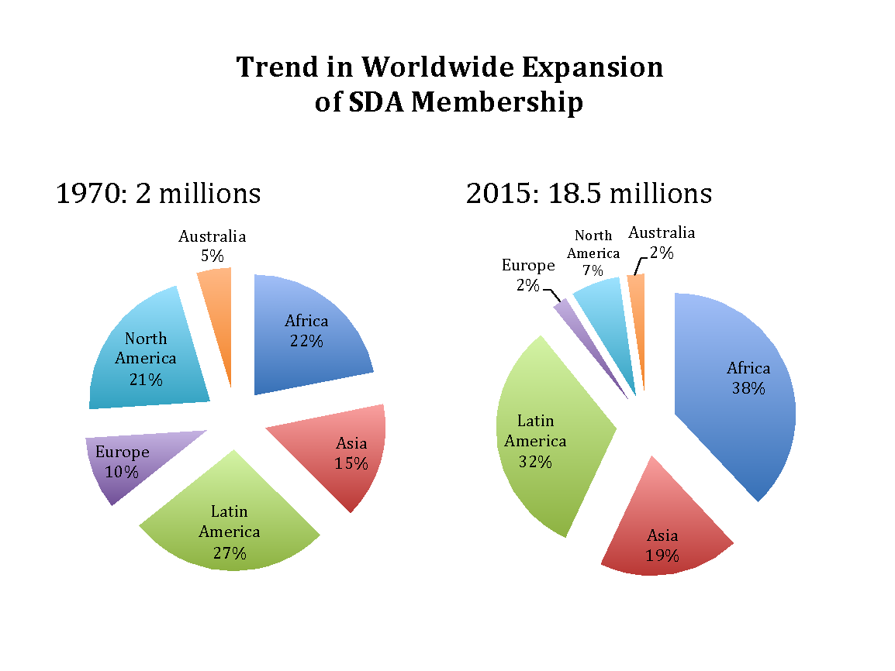
Although it is exciting to see these growth statistics, it is important to look closer to see the context of such growth. The SDA church is a growing, worldwide movement. As stated before, it has grown from 2 million members in 1970 to 18.5 million in 2015. However, church membership in North America has shrunk from 21% in 1970 to just 7% in 2015. Moreover, the growth in North America is predominantly through multi-ethnic groups, immigrants, and refugees. Recent figures show that that 52% of those baptized into the North American SDA church in 2015 were from ethnic minorities. If the trend continues, the rate of adding Caucasian members to the church will actually decrease.
Some researchers involved in congregational study have agreed there are three types of relationships central to church vitality. These relationships seem to naturally fit in the missional matrix we have discussed in previous section.
- Relationship with God (Christology)
- Relationship with others in the church (Ecclesiology)
- Relationship with the world (Missiology)

Relationship with God
The data collected from pastors and leaders in 2015 provide a snapshot of Sabbath school (religious education). Although the attendance and participation in Sabbath school has diminished, it is still strength of Adentistm, as knowing God is at the core of Adventist identity. The average Sabbath School attendance is higher in Adventist churches (an average of 50 attendees per week) when compared with other denomination’s Sunday School attendance (an average of 40 attendees per week). The percentage of lay people involved in this kind of religious education among Adventists is also much higher than all other faiths involved in the research.
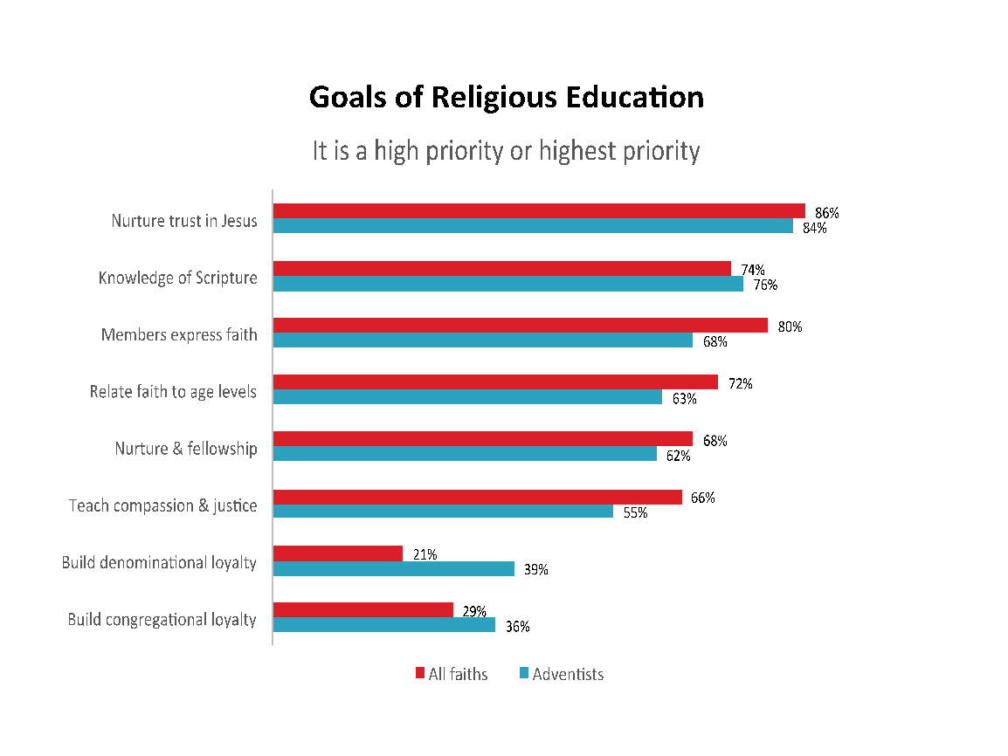
The number one goal of Sabbath School in NAD Adventist local churches in is “to nurture belief and trust in Jesus Christ” based on the 84% of local leaders who reported that this was either the “highest priority” or a “high priority” for their congregation. The second-ranking goal is “to acquire knowledge of the Scripture,” indicated by three out of four local leaders (76%). About two thirds of the respondents gave similar responses for three other goals: 68% for “inspire members to express their faith in life,” 63% for “relate your faith’s beliefs and practices to each age-level,” and 62% for “engage members in nurture and fellowship.“ Over half (55%) also indicated that it is a priority to “teach about love and justice toward others.”
Two goals were not reported as a priority in most Adventist churches: only 39% indicated that it was a priority to “develop denominational loyalty” and just 36% said it was a priority to “develop congregational loyalty.” This suggests that matters of personal faith are more important to most Adventists than are organizational relationships.
The priorities expressed in the interfaith sample of United States congregations are not much different than those identified by the Adventist congregations. Adventists are much more likely to say that developing denominational loyalty is a priority, and significantly less likely to say it is a priority to inspire members to share their faith, teach about compassion and justice toward others, and relate faith to all age groups. The difference on the other four survey items is not statistically significant.
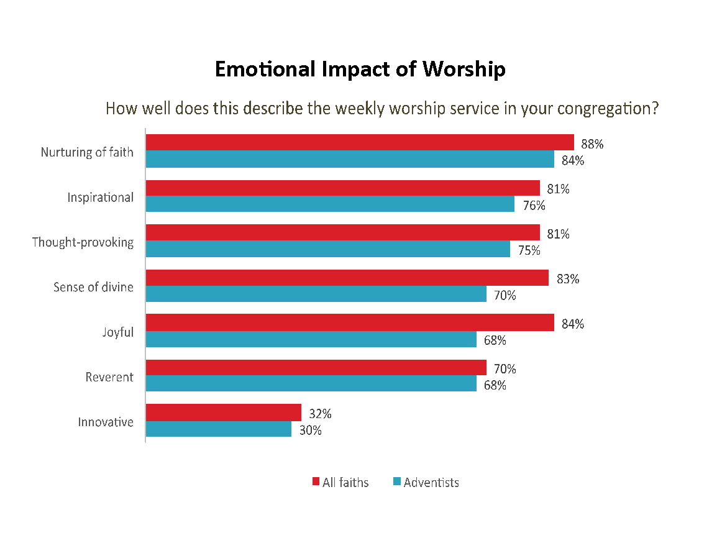
When it comes to emotional aspects of relationship with God, not all of the news is good. The percentages displaying emotional impact of worship combine the “very well” and “quite well” responses for each quality. The Adventist local churches gave somewhat more conservative responses on each item than the overall, interfaith sample of American congregations, although for most of the items the difference is not statistically significant. Only two dimensions have a significant difference: Adventist churches are less likely to report joyful worship services and a sense of God’s divine presence in worship.
The NCD data related to worship service seem to support similar findings. While Adventist exceed in learning about God, the overall quality of worshipping God is below average in comparison with other Christians.
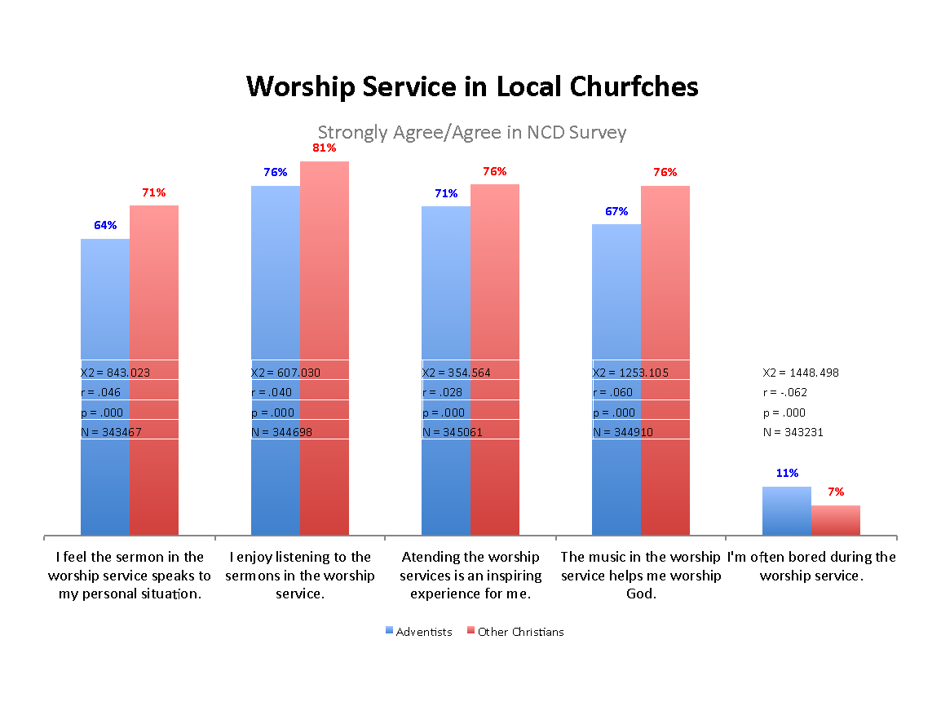
Eleven percent of Adventist respondents actively involved in church indicated that they are bored during the worship service, compared with only 7% of respondents of other Christians. Two thirds (67%) consider the church music helpful in worshipping God, more than seven out of ten (71%) active Christians consider attending worship as an inspiring experience, over three in four (76%) enjoy listening sermon, and nearly two out of three (64%) find sermons relevant.
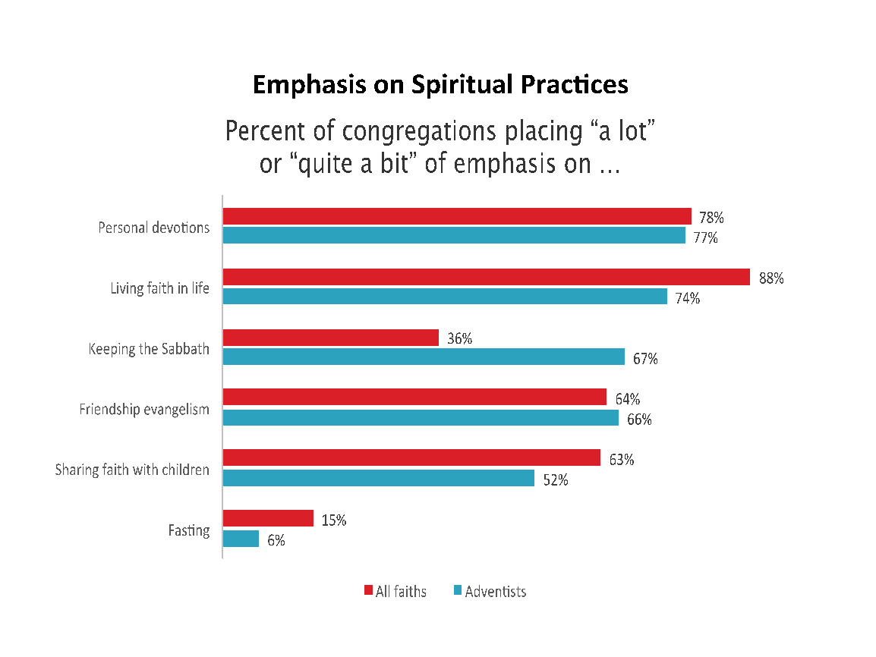
Respondents were asked how much emphasis their congregation gives to each of six spiritual practices with five possible responses for each item; a lot, quite a bit, some, a little or not at all. Adventist local churches in North America were significantly more likely than the overall sample of religious congregations in the United States to indicate greater emphasis on “keeping the Sabbath day holy,” but significantly less likely to emphasize “fasting, living out one’s faith in all aspects of one’s daily life” (including work, family, civic engagement, etc.) and parents talking with children about faith.” The difference between Adventist churches and all faiths on the other two items is not statistically significant. The actual language for friendship evangelism was “talking with friends and other members of the congregation about one’s faith.” The actual language for personal devotions was “personal prayer, meditation, scripture study, devotions or other spiritual practices.”
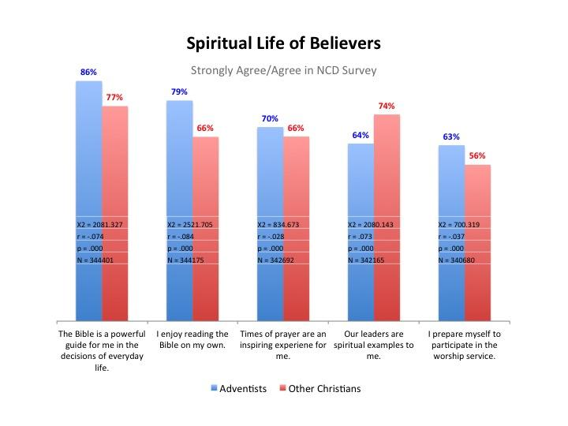
The vast NCD survey data has brought forth how much Seventh-day Adventists are passionate about Scripture compared to other Christians. Over four out of five (86%) of active church members reported that they view the Bible as a powerful guide in the decisions of everyday life; for those outside of the Adventist faith, only 77% of congregations placed the same value on the Bible as a guide. Also, nearly 80% of Adventist respondents indicated that they greatly enjoy spending time reading the Bible on their own. Only two-thirds (66%) of respondents of other faiths indicated that they enjoy reading the Bible on their own. Seven out of ten (70%) active Adventists consider time of prayer as an inspiring experience compared to the 66% of other Christians, and 63% of Adventists prepare themselves for participation in Sabbath worship service compare to 56% of other Christians who claim to prepare for Sunday worship service. Only 64% of Adventists (10% less than other Christians), however, consider their leaders as spiritual examples.

Relationship with Others in the Church
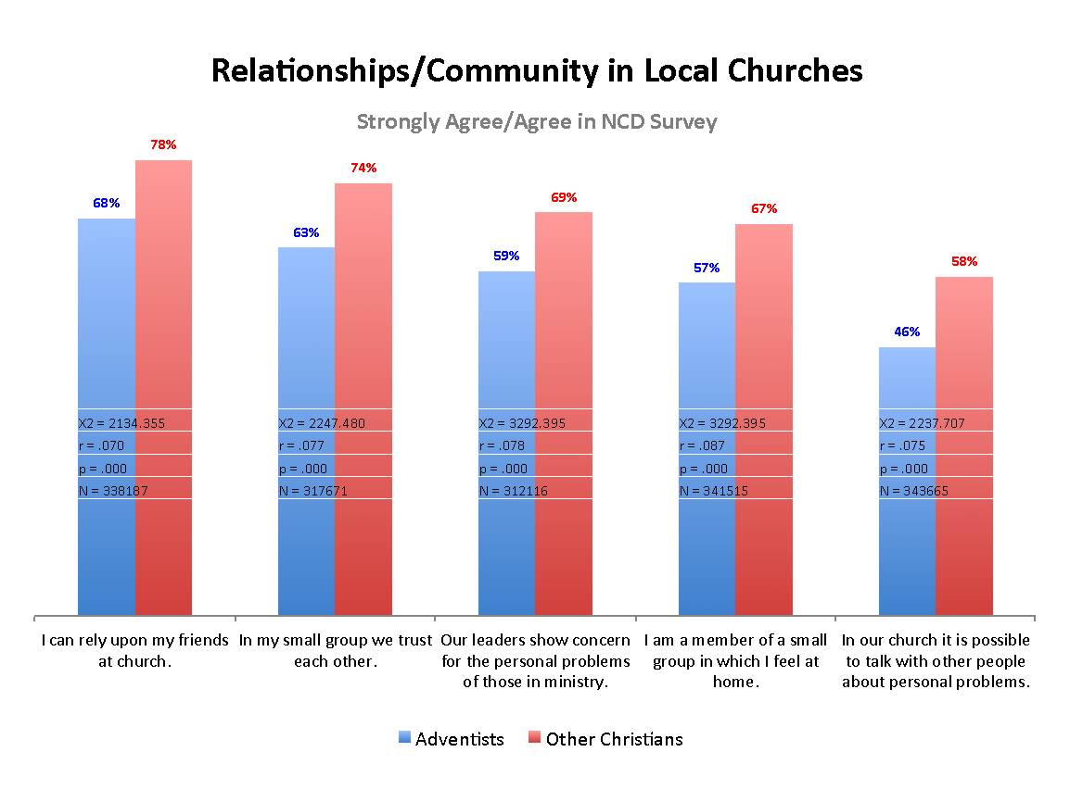
So far we have reviewed findings dealing with how Adventists relate to God through Sabbath School religious education, worship experience, and spiritual practices. How do Adventists relate to each other compare to other Christians? The chart “Relationships/Community in Local Churches” portrays data collected over the past eight years in less favorable figures for Adventists compared to other Christians. Loving relationships in church, as well as in small group setting, are somewhat a challenge. When compared to other Christians, Adventists ranked lower in all relational areas than did their counterparts. Sixty eight percent of Adventists agreed that they could rely on their friends in the church (10% less than other Christians). Less than two thirds of Adventists (63%) reported they could trust each other in small group setting (11% less than other Christians). Fifty nine percent of Adventists perceived their leaders show concern for the personal problems of those involved in local church ministry (10% less than other active Christians). Fifty seven percent of Adventists admitted they were part of a small group in which they felt at home (10% less than other Christians). Only 46% of Adventist claimed it was possible to talk with other people about personal problems in the church (12% less than the rest).
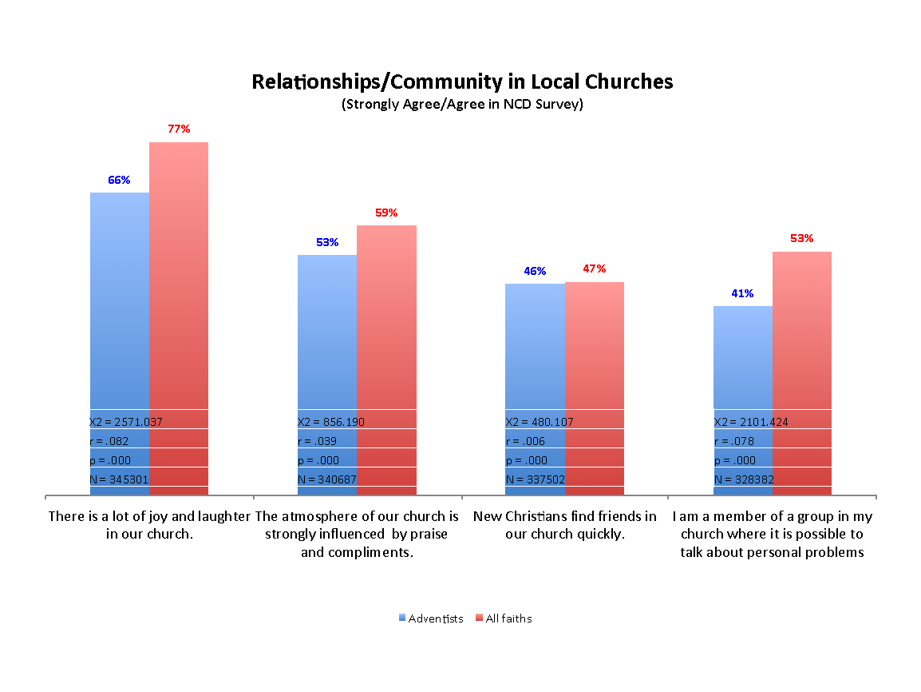
Sixty six percent of Adventists indicated they felt there is a lot of joy and laughter in their church, while 77% of other denominations felt the same. Fifty three percent of Adventist respondents indicated the atmosphere of their church is strongly influenced by praise and compliments, while 59% of non-Adventist respondents indicated the same. Forty one percent of Adventists indicated that they are members of a group in their church were it is possible to talk about personal problems, while 53% of other Christians reported the same. The only area in which Adventist respondents ranked their relational experiences close to that of non-Adventists is in the area of new Christians quickly finding friends in their church.
However, there is some good news in this area! The surveys of active Adventists collected in the preceding period of 1995-2008 ranked all areas lower than the surveys collected 2008-2016. While there is still much room for improvement in interpersonal relationships within the church, it appears that Adventist churches are making positive changes in the right direction.

Relationship with the World
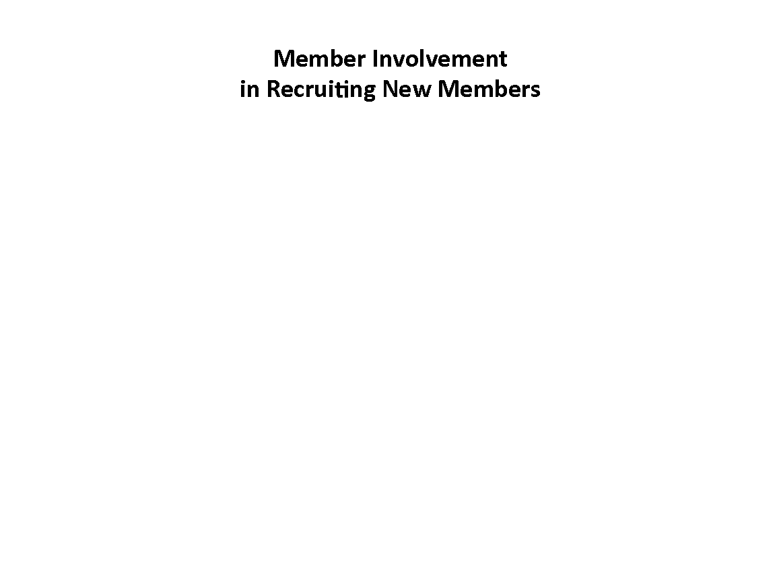
The FACT research has brought an interesting comparison of involvement of church members in evangelizing (i.e. recruiting of new members). Respondents were asked to describe the extent of involvement by “participants” in “recruiting new people.” On this item, there is a definite difference between Adventist local churches in the North American Division and the overall sample of all religions in the United States. Compared to other Christian denominations, there are twice as many Adventist congregations reporting “quite a bit” of involvement by members in recruiting new people and significantly more who report “some” involvement by members, as well as significantly fewer who report only “a little” involvement. Clearly, the people in the pews in Adventist congregations are more involved in personal outreach and bringing new people into the life of the congregation than are many other religions in America.
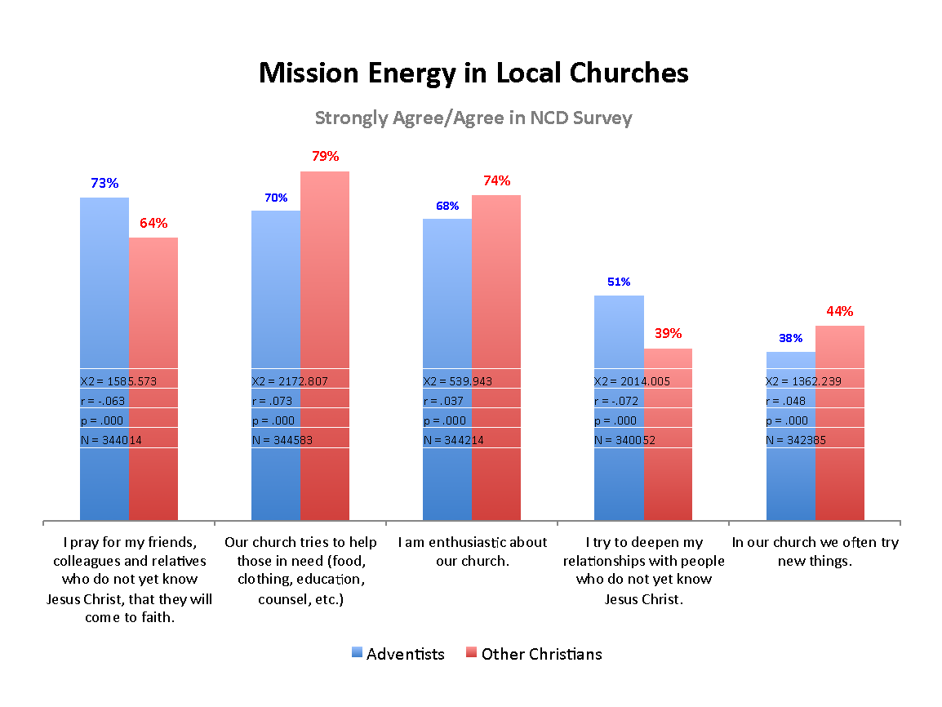
The same pattern is evident in NCD data as well. Seventy three percent of Adventists agreed they pray for friends, colleagues, and relatives who do not yet know Jesus Christ would come to faith (9% more than other Christians). More than half of the Adventist respondents reported they try to deepen relationships with people who do not yet know Jesus Christ (12% more than other Christians). Seventy percent of Adventists agree their church tries to help those in need, which is 9% less than in the churches of other Christians. A little over two thirds of Adventists (68%) stated they were enthusiastic about their church (6% less than other Christians). Finally, only 38% of Adventist agreed they often try new things in their churches (6% less than other Christians).

Road to a Positive Change?
In our assessment of the vitality of SDA churches in the NAD as portrayed in three basic relationships (or missional matrix), we have encountered both strengths and weaknesses. The present strengths and weaknesses describe who Seventh-day Adventists are. If we were to summarize the key findings in a brief statement, it would read as follows:
- Greater importance of head knowledge over heart experience in the spiritual realm
- Stronger emphasis on reaching the lost people at the cost of lesser emphasis on developing and nurturing a loving community of believers
The trends have not happened overnight, and it may not be easy to change them. However, as we face the present challenges of losing connection with younger generations and not reaching post-modern secular people, we need to consider the possibility of positive changes. What are chances the NAD is going to be made up of vibrant, healthy, growing churches in 20 years? That is directly linked to the present ability and readiness to change. Let’s take a closer look at what the data has revealed.
NAD local churches report somewhat greater barriers to change and growth than is the norm for religious congregations of all faiths in the United States. However, for three of the five factors included in the study, the difference is not statistically significant. Adventist churches are significantly more likely to report that “strong resistance from some church members” is a barrier to change. This suggests that the views of a relatively small number of very traditional church members, perhaps supported by certain ministries and independent groups, may tend to “hold hostage” the will of the majority in many congregations who are seeking to increase their vitality and viability.
Adventist churches are also significantly more likely to report that a lack of a unifying, energizing vision is a problem. The other three factors that inhibit change in NAD local churches are similar in importance to that reported by the overall sample of all faiths: lack of energy and finances; lack of workable, concrete models; and leaders who do not want to be too far ahead of the congregation in seeking change.
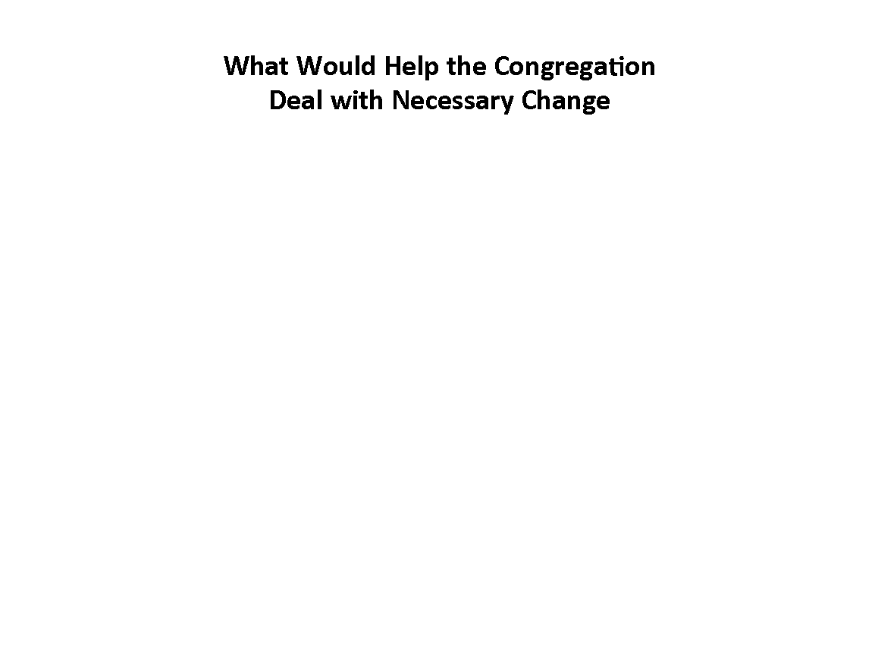
What would help the congregations to deal with necessary changes? According to the majority of respondents, leaders who are trained to manage change would be the most helpful of all the listed items. A total of 59% indicated that it would be “much help” or “some help.” Nearly half (49%) gave the same responses to the use of assessments of the congregation and the community where it is located. Forty five percent indicated that advice and funding from the denomination would help their local church deal with necessary change, while 41% gave the same responses to familiarity with concrete models or stories of churches that successfully dealt with change or demonstrate the usefulness of making changes.
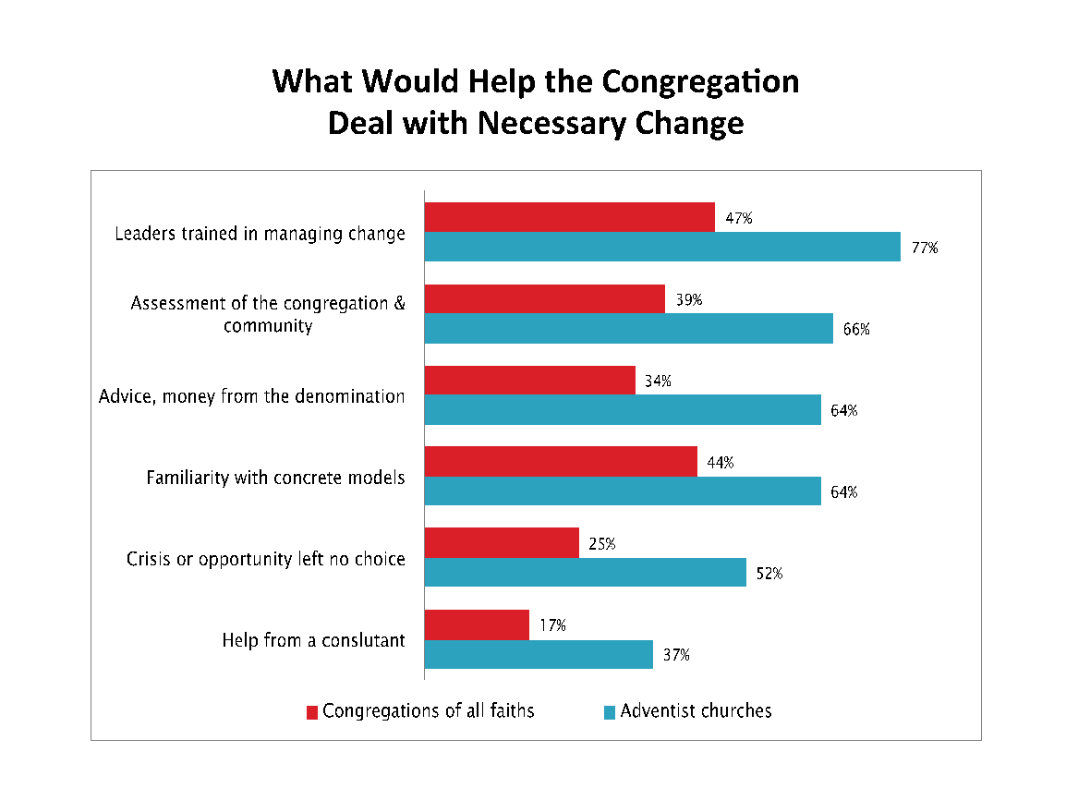
Less than a third of the respondents indicated that if their local church faced a crisis or an opportunity that left them no choice but to change, it would help the congregation deal with the necessary change. This response indicates how entrenched the resistance to change is in many local churches in the NAD. Further research is needed to understand why not changing has become such a sacred object for most Adventist churches in the United States. Such resistance to change is likely to become a major barrier to church growth and mission in the future. Consultants may be a useful tool in dealing with change; however, it is likely that the response to this item includes a large number of non-responses simply because many pastors and elders have no experience with this kind of service.
The good news is that the local churches in the NAD are significantly more likely to agree to the usefulness of various kinds of assistance in dealing with change than are congregations of all faiths in the United States. All six of the strategies to help congregations deal with change that were included in the survey show a significantly higher level of positive response by Adventist churches than the overall sample of all religious congregations. This may simply be a reflection of the degree to which Adventist congregations have a closer relationship to the local conference than is typical for American denominations. It may also indicate that the NAD needs to give greater attention to the need to help local churches deal with change.

Tools Fostering Vibrant Healthy Growing Church
After the topic of this study has been treated theologically, as well as through social science assessment, it is now appropriate to focus on answering the “so what?” question and explore ways how can the findings be addressed in practical ways. Are there any tools available that can help our churches to grow healthier?
In this last section, we present three tools that are available in the NAD that can help SDA local churches to become missional churches, grow healthier and yet stay balanced, while cherishing Christ’s radical Spirit. Upon briefly describing each tool and their characteristics, we present the strengths of each tool based on interviews with SDA pastors who have already been using the tools in their churches.

Church of Refuge (COR)
Church of Refuge (COR) is based on the Biblical tenets of cities of refuge in ancient Israel. These cities were strategically placed to provide a place of refuge for persons seeking shelter. Like these shelters of old, COR seeks to provide a safe haven for young people. These churches provide an accepting and inclusive faith community where members can grow spiritually and develop a strong friendship with Jesus (Whitehead 2008).
COR is a tool developed in Center of Youth Evangelism at Andrews University based on research among young adults about the values that are important for them in their church. COR provides a framework of values on which to build the church life rather than on mere numbers (such as number of members, number of attendance, number of programs, number of baptisms, number of people leaving, number of people coming, number of tithe payers, number of $ collected, etc.). Churches are encouraged to operate around these values and the way to measure success is to assess how the churches live by the values. A way to evaluate progress is by a repeated survey.
COR adheres to promote and live out 9 main principles:
- Sabbath
- Discipleship
- Acceptance
- Community
- Support
- Service
- Leadership
- Budget
- Innovation
These critical factors are based on Biblical teachings, as well as pastoral leadership, Ellen G. White references, and research.
There are several steps involved in becoming a certified Church of Refuge. The first step is registration with the Church of Refuge Network. After registration, the church will complete a written description of the church’s progress and performance in the nine COR guiding principles. Certification is completed with an onsite visit by COR leadership that incorporates interviews with leaders and members. Re-certification takes place annually, and churches submit an annual report on young adult ministry activities (COR website: http://www.cye.org/article/170/cye-ministries/church-of-refuge).
COR tools came to exist within SDA church, and were developed from the level of the local church. Although COR has been around for eight years, it is still in a testing phase. This tool allows local churches to be intentional about their mission and development. This tool also offers to the local church help of a coach. It is cost free.

Mission Driven Church (MDC)
Mediocrity is a common problem in many churches, as they settle for “good” instead of aiming for “great” churches. A lack of a unifying vision to reach the world makes the church fall short of the mission that God intended for His church. Mission Driven Church (MDC) presents five steps for creating an exceptional church that follow the acronym BASIC:
- Build a team
- Agree on a mission and strategy
- Strategize in writing
- Implement your strategy
- Create a culture.
In addition, the mission driven program underscores the importance of a church creating a vision that centered on revival and transformation, education for discipleship, alignment within the church, community outreach and evangelism, and healthy leadership (REACH). Having core values is essential for developing mission. When all church ministries align to the overall vision of the church, the church operates united.
Following the BASIC approach in planning with mission in mind helps the church stay focused on the vision of reaching their communities for Christ. Churches are encouraged to choose three main goals as priority and align all the functions/ministries of the church to those goals. As goals are met, new mission minded goals can be set and again, the functions and ministries of the church planned with those new goals in mind. The North American Division has developed a website, www.ReachNAD.org, with tools and resources to help churchs along each step.
MDC is a tool developed directly by North American Division (Brantley et al. 2015) and recommended to the local churches by top leadership. It aims to help the churches to become excellent and missional. It is still in a testing phase but the feedback from pilot churches is very positive. This tool also offers to the local church help of a coach. It is cost free.

Natural Church Development (NCD)
Natural Church Development (NCD) is a process through which the health of churches can be evaluated and improved. NCD is broken down into the following eight categories:
- empowering leadership
- gift-based ministry
- passionate spirituality
- effective structures
- inspiring worship service
- holistic small groups
- need-oriented evangelism
- loving relationship.
Each of these categories represent Biblically-based characteristics of a healthy church. The survey results identify which of these areas provide opportunity for improvement. When churches focus on their weakest area, usually all the other areas improve (Burrill & Evans 2014:15-22).
To participate in the NCD process, contact the USA NCD partner at www.ncdamerica.org. Once the process is started, 30 church members area selected to take the basic profile survey. Upon completion of the survey, a background analysis of the basic profile is prepared graphically showing the rating on each of the eight elements as well as the average score. Local church can also receive additional analyzes that include overall trends, lowest factors, and changes. In addition, access to individual question answers is available (Schwarz 2005:153). The average score for this survey (based on national norm) is 50 (Burrill & Evans 2014:17).
Survey results are used to help the church plan in a way that moves towards greater health. Churches should focus on three to four specific categories of improvement, ideally the lowest categories. The weakest areas are the ones that hinder church growth the most. The survey should be taken annually to measure growth, progress, and change (Burrill & Evans 2014:18-22). NCD has a variety of tools such as books, web resources, consultants, and coaches to help navigate churches not only through the analysis but also through the development towards greater health (Schwarz 2004:158-159).
In the last 25 years, this tool has generated 70,000 church profiles in 70 countries across various denominations. This tool has been embraced by and utilized among hundreds of SDA local churches in various countries and has helped to revitalize number of churches. SDA authors have written books examining the nature of NCD principles and its harmony with the Bible and SDA fundamental beliefs (Folkenberg 2002; Burrill 2004; Burrill & Evans 2014).
NCD has been developed in Germany outside of SDA church (www.NCD-international.org) based on Biblical research, research of nature and social science research of churches around the world. This tool includes help of a coach to the local churches. The basic church profile costs $195.

Conclusion
The first part of this paper outlined the context of the present discussion about healthy growing churches. It has also outlined the theological basis for healthy growing church. A missional church is a church with well-balanced Biblical theology in areas of Christology, missiology and ecclesiology. The SDA church has very well-developed Biblical theology dealing with fundamental beliefs. However, amidst the present crisis of authority, with young people leaving the church disappointed and disillusioned, and with the difficulties to reach postmodern secular people, the concept of the missional matrix becomes relevant. The Seventh-day Adventist Church in NAD is recommend to further study and develop the theology of mission, as well as missional ecclesiology and Christiology taking in account Jesus teaching about Kingdom values.
The second part of this paper assessed the health and vitality of the Seventh-day Adventist Church in North America. We have presented empirical evidence of the predominant strengths, as well as the weaknesses, the SDA church in the NAD presently faces. We have set forth the SDA pattern of placing greater importance of head knowledge over heart experience in the spiritual realm. We have also presented evidence of stronger emphasis on reaching the lost people at the cost of lesser emphasis on developing and nurturing a loving community of believers. We have assessed the semi-openness of SDA church towards change.
Research has shown healthy and vital churches are doing better than plateauing dysfunctional churches. Empirical research has also demonstrated churches can turn around. This paper also provided a list of currently used/developed tools that can help churches to grow healthier. The tools were described and evaluated for practical application. The following table shows brings summary of our discourse.

 | COR | MDC | NCD
Origin | SDA | SDA | Non-SDA
Direction | From below | From top down | From outside
Phase of development | Testing phase | Testing phase | Mature, developed
Emphasis | Youth values | Business excellence | Organic health
Reach | In-reach | Outreach | Outreach, In-reach
Cost | Cost free | Cost free | From $195 up
Assessment tool | Questionnaire | Feedback surveys | Questionnaires
Related research | Biblical, survey in local churches | Biblical, literature | Biblical, scientific
Outside help | Coach, consultant, pastor | Coach, administrator, pastor | Coach, trainer, pastor
Key words | 9 Values, survey, certification, youth involvement | Mission, vision strategy, feedback, BASIC excellence | 8 qualities, church profile, minimum factor, health

The purpose of the practical application was to evaluate the strengths and possibilities of proposed tools. Each tool may attract different churches, based on their preferences and inclination. For some church leaders, it is important to embrace young adults (COR). For others, it is important the church functions as a living organism (NCD). Still others would like to see their church doing God’s business and want to manage their church to do it exceptionally (MDC). All tools require both pastor and lay people involved, and all tools allow the church and lay leaders to continue with the current pastor. May churches benefit from these tools and grow healthier to become the vibrant churches we have only dreamt of so far.

Bibliography
Andiñach, Pablo R. 2014. Being Church: An Ecclesiology for the Rest of Us. Eugene, OR: Cascade Books.
Beach, Lee. 2015. The Church in Exile: Living in Hope After Christendom. Downers Grove, IL: IVP Academic.
Bosch, David J. 1991. Transforming Mission: Paradigm Shifts in Theology of Mission. Maryknoll, NY: Orbis Books.
Brantley, Paul, Dan Jackson, and Mike Cauley. June 2015. Becoming a Mission-Driven Church: A five-step strategy for moving your church from ordinary to exceptional. Tampa ID: Pacific Press.
Bryan, Alex. 2014. Ecclesiology and The One Project. Paper presented for ASRS conference. Accessed 1 November 2016. https://lasierra.edu/fileadmin/documents/religion/asrs/4_Alex_Bryan.pdf
Bryant, G. Alexander. 2016. Secretary’s Report: North American Division 2016 Year End Meetings. Accessed 1 November 2016. http://www.nadadventist.org/site/1/2016%20images/2016%20NAD%20Secretary%20Report%20G.%20Alexander%20Bryant.pdf
Burrill, Russell. 2004. Waking the Dead: Returning Plateaued and Declining Churches to Vibrancy. Hagerstown, MD: Review & Herald Publishing Association.
Burrill, Russell, and Tom Evans. 2014. Creating Healthy Adventist Churches Through Natural Church Development. NADEI.
Chester, Tim, and Steve Timmis. 2008. Total Church: A Radical Reshaping around Gospel and Community. Wheaton, IL: Crossway.
Folkenberg Jr., Robert. 2002. Health for the harvest. NADEI.
Gelder, Craig Van. 2007. The Ministry of the Missional Church: A Community Led by the Spirit. Grand Rapids, MI: Baker Books.
Guder, Darrell L. ed. 1998. Missional Church: A Vision for the Sending of the Church in North America. Grand Rapids, MI: William B. Eerdmans Publishing Company.
Hegstad, Harald. 2013. The Real Church: An Ecclesiology of the Visible. Eugene, OR: Pickwick.
Hill, Graham. 2012. Salt, Light, and a City. Eugene, OR: Wipf & Stock.
Hirsch, Alan. 2009, 5th ed. The Forgotten Ways: Reactivating the Missional Church. Grand Rapids, MI: Brazos Press.
Hybels, Bill and Lynne Hybels. 1995. Rediscovering Church: The Story and Vision of Willow Creek Community Church. Grand Rapids, MI: Zondervan.
Johnson, Douglas W. 1989. Vitality Means Growth. Nashville, TN: Abingdon Press
Lewis, Robert, and Wayne Cordeiro. 2005. Culture Shift: Transforming Your Church from the Inside Out. San Francisco, CA: Jossey-Bass.
Miller, Herb. 1990. The Vital Congregation. Nashville, TN: Abingdon Press.
Rice, Richard. 2014. From Adventist anthropology to Adventist ecclesiology. Paper presented for ASRS conference. Accessed 1 November 2016. https://lasierra.edu/fileadmin/documents/religion/asrs/14_Richard_Rice.pdf
Roxburgh, Alan J. 2011. Missional: Joining God in the Neighborhood. Grand Rapids, MI: BakerBooks.
Schwarz, Christian. 2004. Color Your World. St. Charles, IL: ChurchSmart.
Shawchuck, Norman, and Gustave Rath. 1994. Benchmarks of Quality in the Church: 21 Ways to Continuously Improve the Content of Your Ministry. Nashville, TN: Abingdon Press.
Snyder, Howard A., and Daniel V. Runyon. 2002. Decoding the Church: Mapping the DNA of Christ’s Body. Grand Rapids, MI: Baker Books.
Spader, Dann, and Gary Mayes. 1991. Growing a Healthy Church. Chicago, IL: Moody Press.
Stetzer, Ed, and David Putman. 2006. Breaking the Missional Code: Your Church can Become a Missionary in Your Community. Nashville, TN: Broadman and Holman.
Stetzer, Ed, and Mike Dodson. 2007. Comeback churches: how 300 churches turned around and yours can too. Nashville TN: B & H.
Wagner, Peter. 1987. Strategies for Church Growth. Ventura, CA: Regal Books.
Warren, Rick. 1995. The Purpose-driven Church: Growth Without Compromising Your Message And Mission. Grand Rapids, MI: Zondervan.
Wenger, Rob, and Jack Magruder. 2012. Missional Moves: 15 Tectonic Shifts That Transform Churches, Communities, and the World. Grand Rapids, MI: Zoondervan.
Whitehead, Ron. 2008. Church of Refuge: A Support Ministry for Youth and Young Adults. Andrews University Paper.
Woodward, JR. 2012. Creating a Missional Culture: Equipping the Church for the Sake of the World. Downers Grove, IL: IVP Books.
Wrenn, Bruce, Philip Kotler, and Norman Shawchuck. 2010. Building Strong Congregations: Attracting, Serving, and Developing Your Membership. Hagerstown, MD: Autumn House Publishing.

